**pH control pseudocode:**

1. Setup
2. Configure serial port
3. Configure input pin
4. Configure pH probe
5. Configure output pin
6. Configure pumps
   1. Set amount of acid/base per pump activation
   2. Set maximum amount of pump activation to prevent overflowing
   3. Set up a counter to keep track of the amount of fluid inside cup.
7. Input desired pH
8. End setup
9. Loop
10. Read value of desired pH in serial.
11. Allow user to change the standard pH value
12. Read voltage value from probe via serial port
13. Apply transfer function: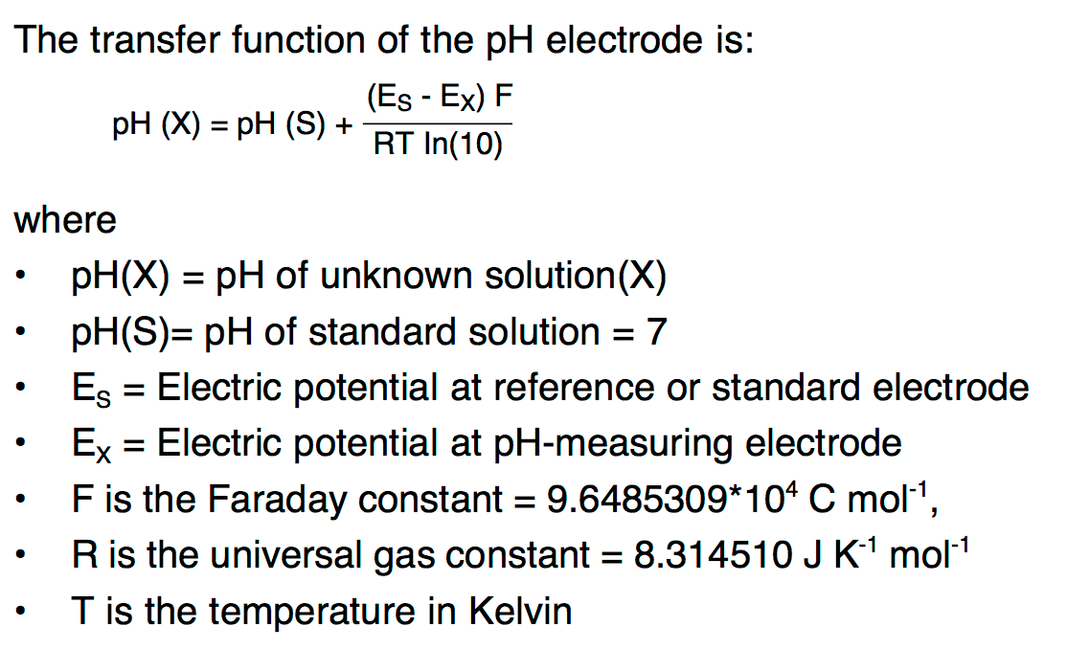
14. Using the calculated pH value, compare it with the standard value
15. Display it on the screen
16. If value is lower: activate base pump once (repeat if necessary)
17. If value is higher: activate acid pump once (repeat if necessary)
18. Pump until pH value is equal to standard value or maximum number of pump activation is reached
19. Delay 100ms
20. End loop

Energia, Processing